**Review Questions - 3.1.2 j,k,l – Classification Processes: Ecosystems – ANSWERS**

# PUBLIC ACCESS MOCKEXAM (2020) MC

# QUESTION 2 (3.1.2 K)

An investigation surveyed a land zone that had

* high precipitation rates
* an open canopy forest with tall emergents and
* a well-developed understorey of ferns, palms and sclerophyll shrubs.

The dominant forest tree species were

* flooded gum (*Eucalyptus grandis*)
* Sydney blue gum (*Eucalyptus saligna*)
* red mahogany (*Eucalyptus resinifera*) and
* brush box (*Lophostemon confertus*).

A dominant vegetation community classification system would classify this ecosystem as a

(A) rainforest.

1. eucalypt woodland.
2. eucalypt open forest.
3. wet eucalypt open forest.
4. **Identify** the two major factors responsible for the distribution of the worlds biomes. (3.1.2 J) (2 marks)

The distribution of the worlds biomes is due to the climatic features such as temperature and water, and the amount and intensity of light.

1. **Explain** how vertical stratification influences species diversity in a community. (3.1.2 J) (3 marks)

Differences in vertical layers in an ecosystem is referred to as vertical stratification. Vertical stratification (layers) in a community results in small variation in abiotic and biotic factors at different depths or heights through the strata.

These differences in abiotic and biotic factors result in a large number of different niches and microhabitats within the community.

This high number of niches and microhabitats results space for increased number of species in separate niches within an ecosystem and thus increased biodiversity.

1. **Contrast** the classification systems ‘Holdridge Life Zones’ and ‘Specht’s Classification of Australian Vegetation’. (3.1.2 K) (2 marks)

The Holdridge life zone system is based on climate conditions and used to designate a predicted plant community on a global scale. In contrast Specht’s classification system uses the structural features of the plants in the area to designate the identify of the community. This is specific to Australian vegetation communities.

1. A particular, humid locality has a potential evapotranspiration ratio of 0.23, an annual precipitation of 7000 mm and biotemperature of 20°C. Using Holdridge’s classification:

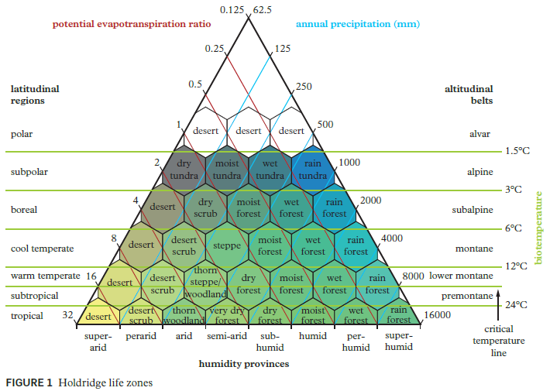

1. **Identify** what type of plant community should be present. (3.1.2 K) (1 mark)

Rainforest

1. **Describe** what latitudinal region this would be found in. (1 mark)

Subtropical latitudinal region

1. The dominant trees in a large area of bushland are brush box (*Lophostemon confertus*) and smooth-barked apple (*Angophora leiocarpa*). Both trees grow to over 30 m in height and have a combined foliage cover of 50%.
2. Given the information provided, **decide** on an appropriate classification system for this ecosystem. (3.1.2 K) (1 mark)

Specht’s classification system.

1. Using this system **classify** the above ecosystem. (3.1.2 K) (1 mark)

In this system, this ecosystem is classified as a tall open forest.

1. Identify three reasons why each of the following ecosystems should be managed. (3.1.2 L)
2. Soils (3 marks)
3. The health of the soil is linked to the ability to grow plants for agriculture.
4. If the soil is managed properly, the quality of the soil can be improved.
5. Water loss and soil erosion can be the result of not managing the soil properly.
6. Coral Reefs (3 marks)
7. Coral reefs protect coastlines from the damaging effects of waves and storms.
8. Coral polyps form a mutualistic relationship with zooxanthellae, which is a photosynthetic organism that transforms energy for the coral reef ecosystem. This increases the otherwise low productivity of these regions.
9. Coral reefs provide nutrients, shelter and habitats for marine organisms, as well as a high density of microhabitats and niches that provide very high biodiversity.